Walchand College of Engineering, Sangli

Computer Science & Engineering

Third Year

**Course Name:**

**Software Engineering Tools**

**Course Code: 5CS351**

**Assignment No-8**

**Name : Akash Babu Misal**

**PRN: 21520005**

Q 1. What are the prerequisites for installing the TestLink tool.

Ans Since TestLink is a web-application it follows the concept of client/server. It means that TestLink can be installed centrally on a server and users can interact with it through web browsers using a website from any computer.

· Web Server − TestLink supports Apache 2.2.2.1. However, it can work with any latest web server software. TestLink only uses .php file. Configure the web server with .php extension only.

· PHP − The web server should support PHP. It can be installed as CGI or any other integration technology. It is recommended to use 5.3.8 PHP version.

· Mandatory PHP Extensions − Extensions for RDBMS are mysqli, pgsql, oci8, sqlsrv. Mbstring is required for Unicode – UTF-8 support.

· Optional Extensions − Curl, GD, Fileinfo

· Database − TestLink requires database to store its data. MySQL (5.5.16) is recommended.

· FileZilla FTP Server − FileZilla FTP Server 0.9.39 is required to install XAMPP as optional.

Q 2. Install TestLink tool on your machine (Provide screen shots for successful installation and login)

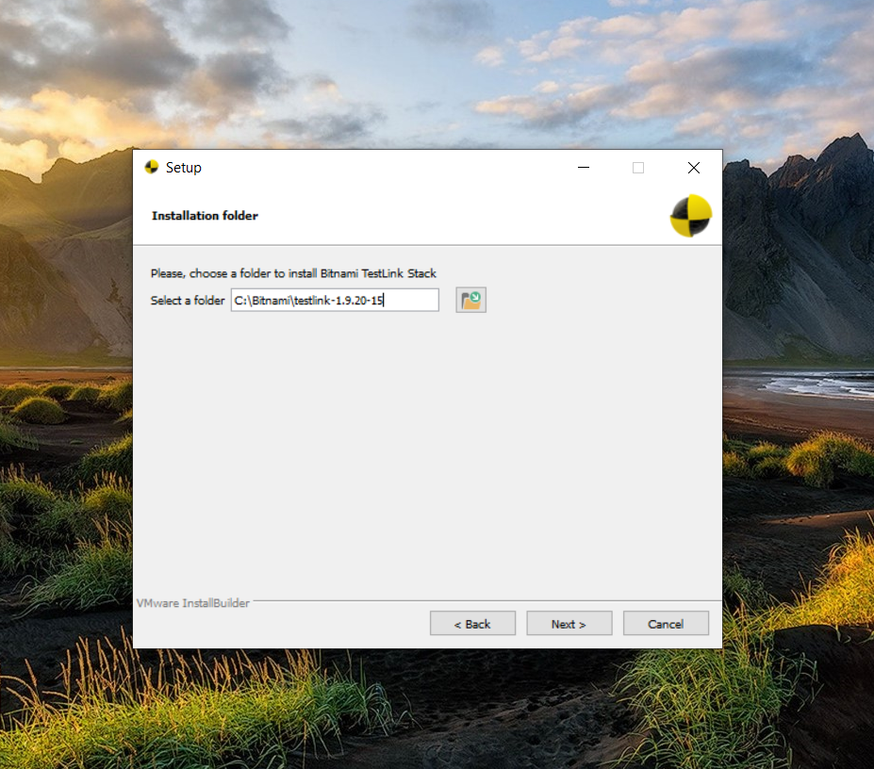

Q 3. Using TestLink tool create multiple test cases (at least 10) on any application/project that you have implemented.

Perform below tasks

a. Create New test project as SETProject

b. Create a test plan as SETProjectTestPlan

c. Create a build as SETProjectBuild

d. Create test suite as Test Suite 1 under SETProject

e. Create Test cases in TestLink Tool

f. Assign created Test Cases to the test plan SETProjectTestPlan

g. Create different roles as given below in the TestLink

|  |  |  |  |
| --- | --- | --- | --- |
| S No. | Role | Test Cases | Test Metrics |
| 1. | Guest | View | View |
| 2. | Tester | Execute | View |
| 3. | Senior Tester | Edit & Execute | View |
| 4. | Leader & Admin | Edit & Execute | Edit & Execute |

Test project

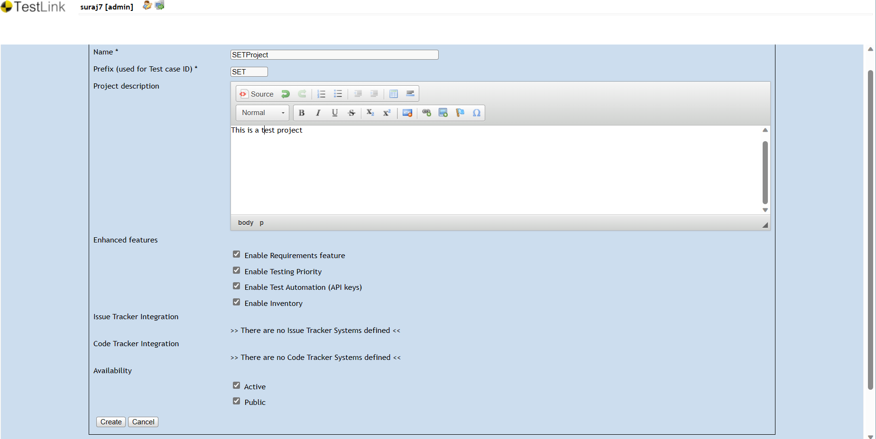

Test plan

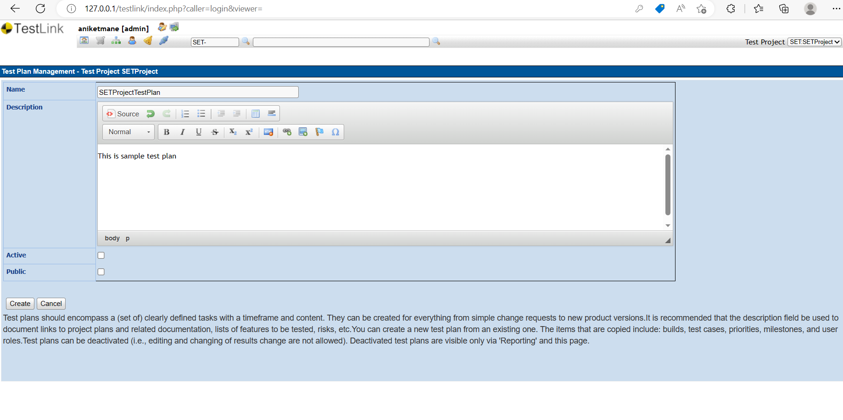

Test suite

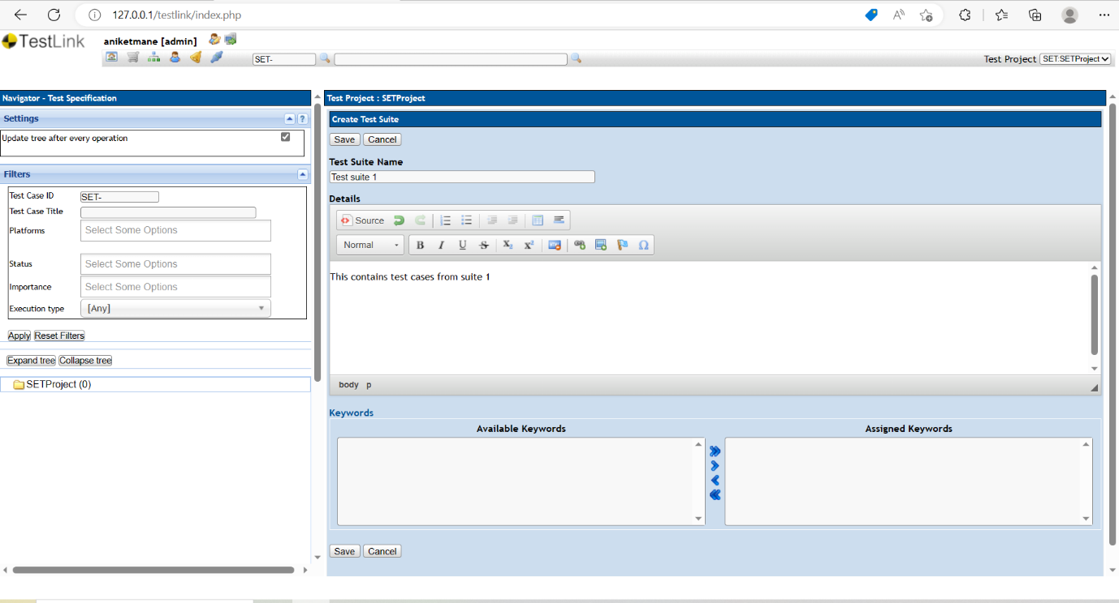

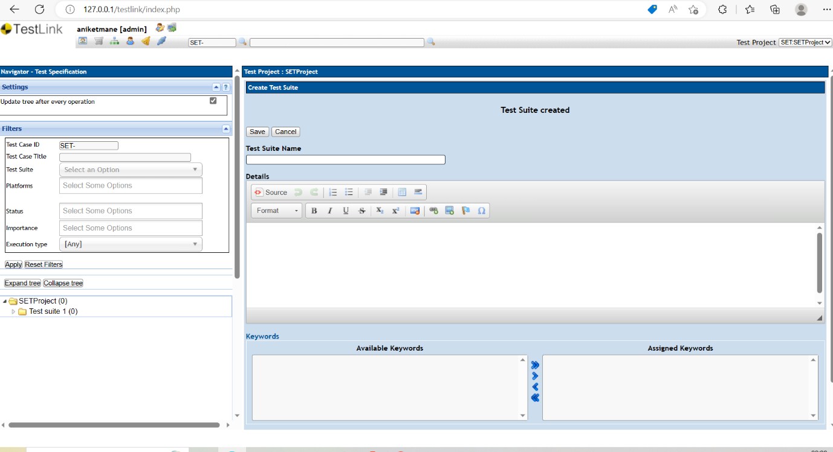

Test case

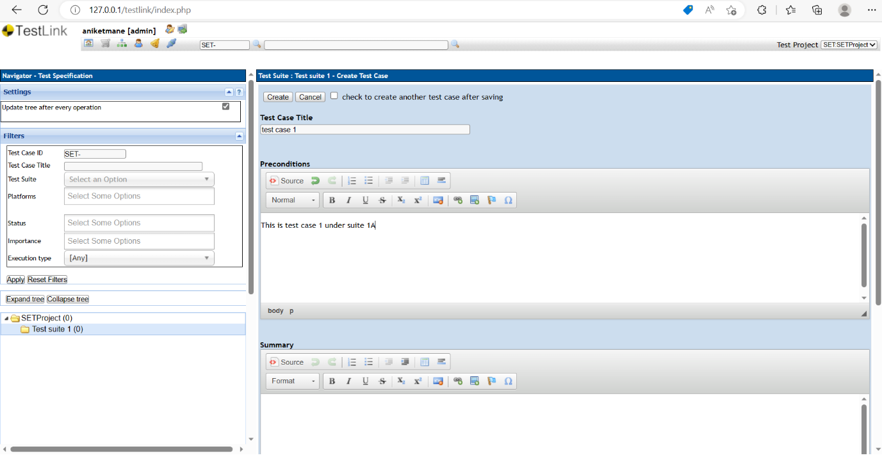

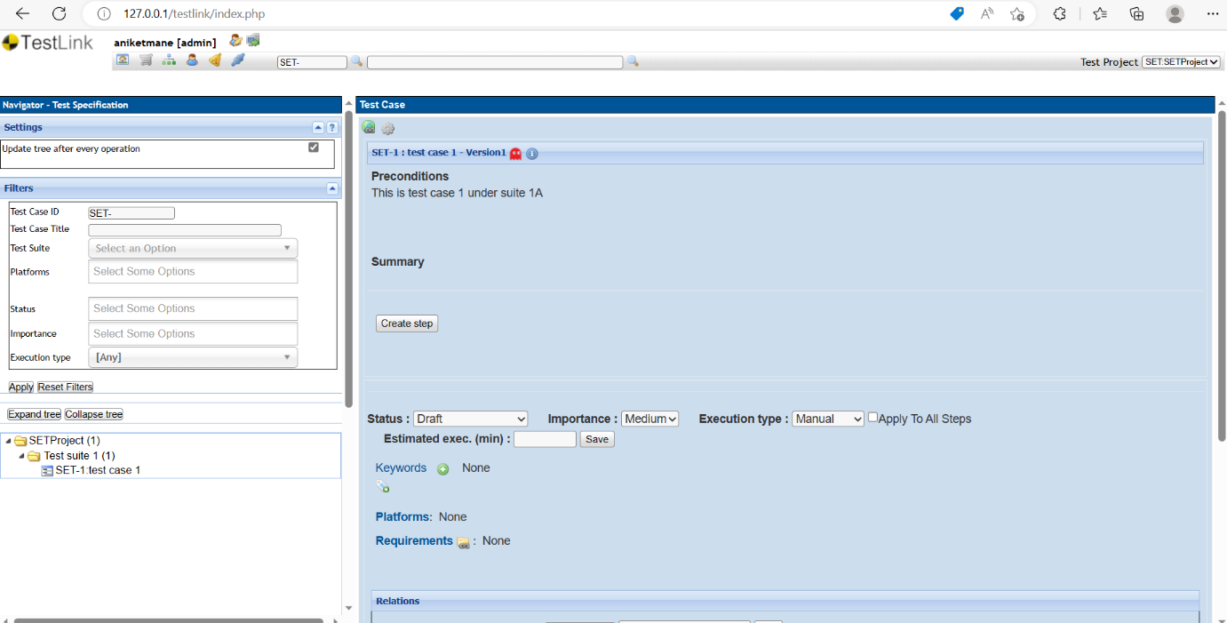

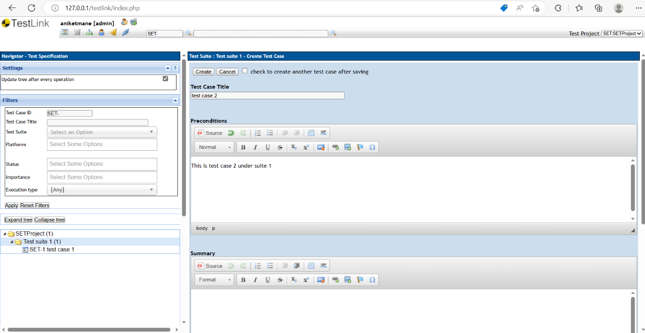

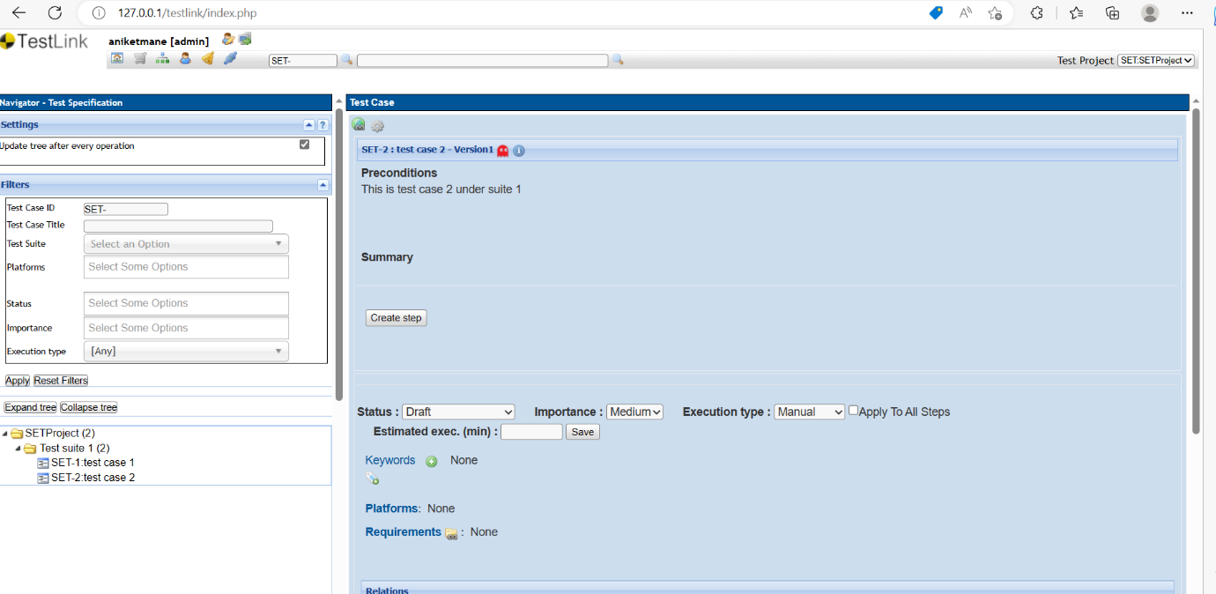

Roles

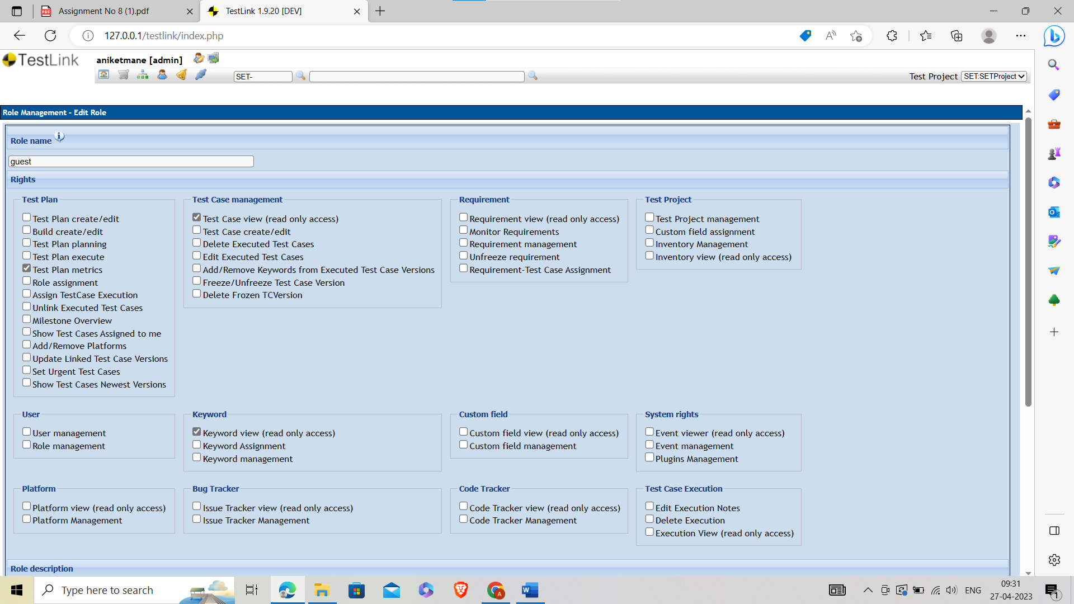

Requirements

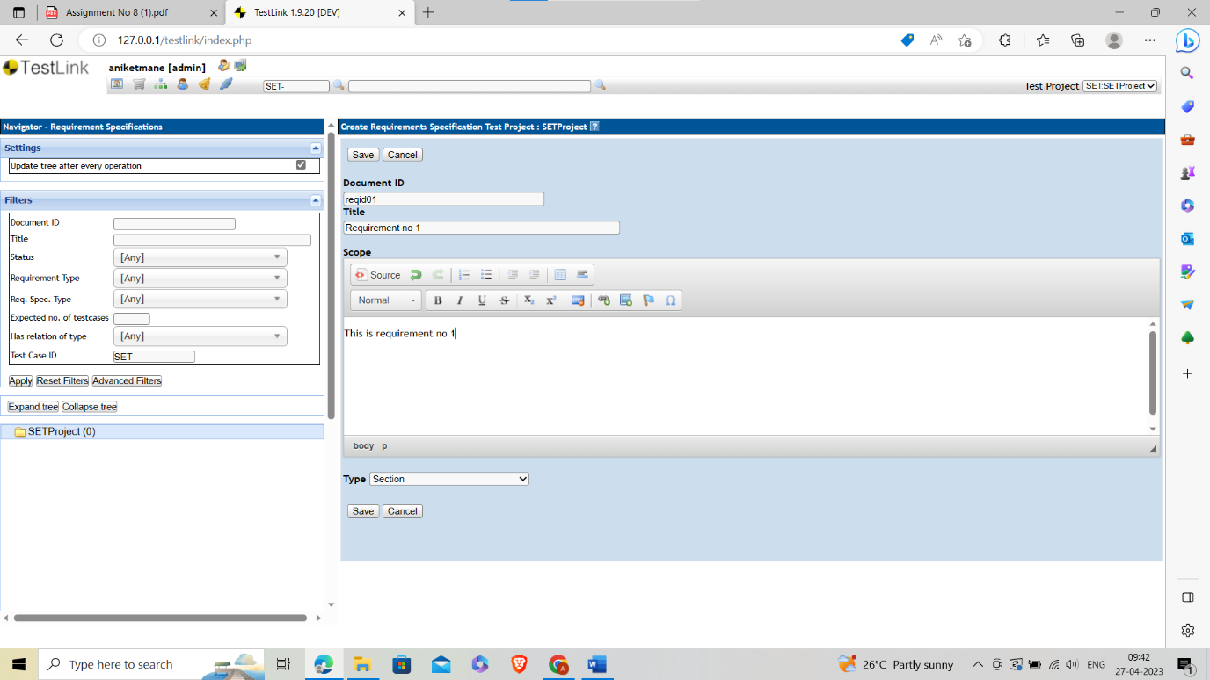

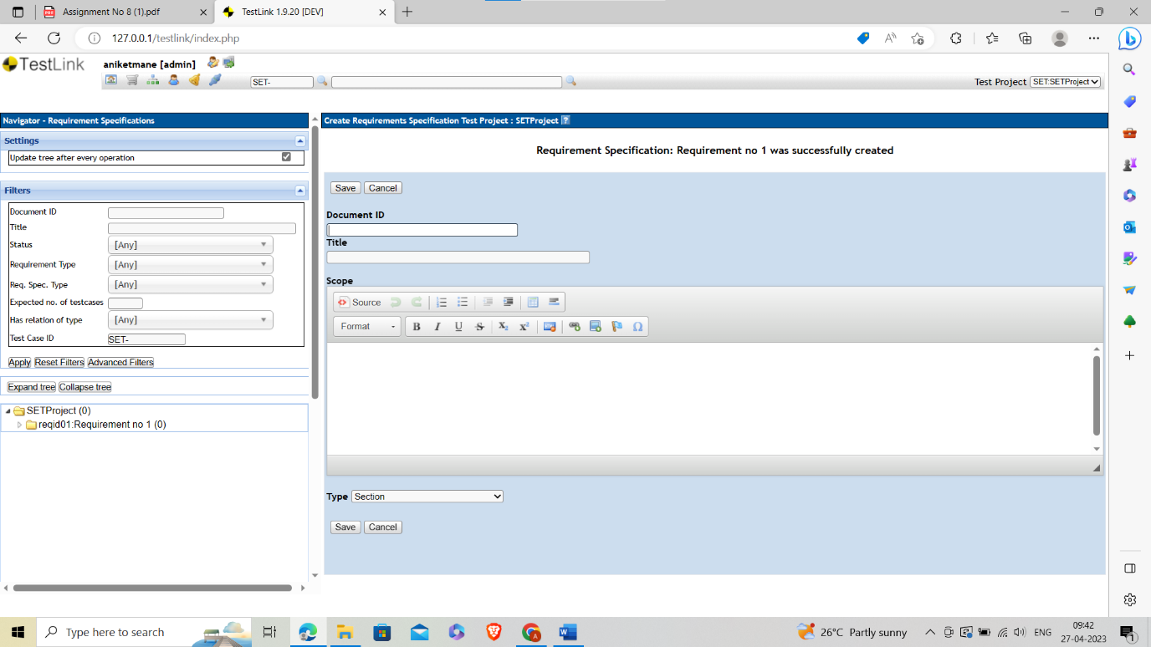

Execution



